LEVEL-2

TASK-1

TABILE BOOKING AND ONLINE DELIVERY

CODE

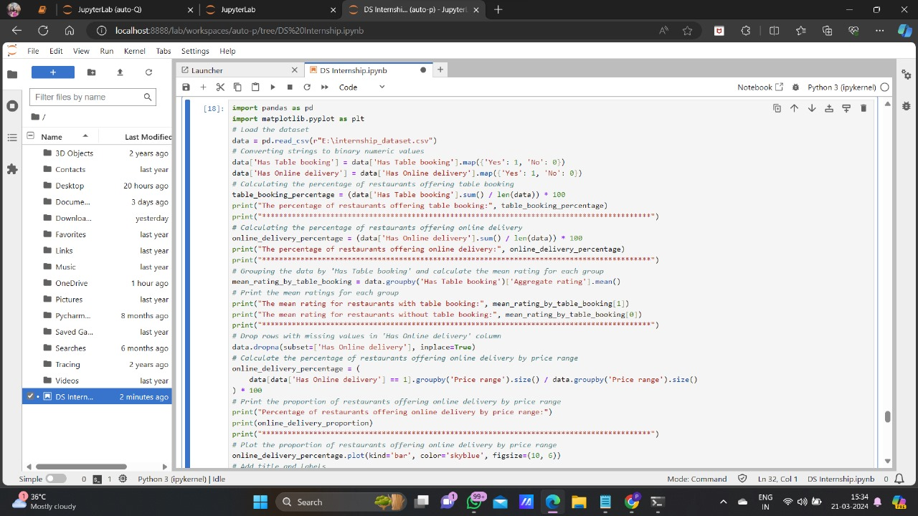

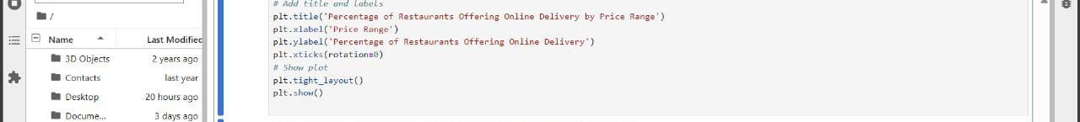

OUTPUT



